*vivo mobile*

vivo y22

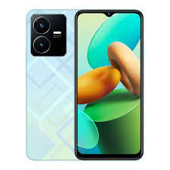

vivo Y22 ; Size, **6.55 inches, 103.1 cm2** (~82.4% screen-to-body ratio) ; Resolution, 720 x 1612 pixels, 20:9 ratio (~270 ppi density) ; OS, Android 12, Funtouch 12.

**PRICE / 45,999 PRK**